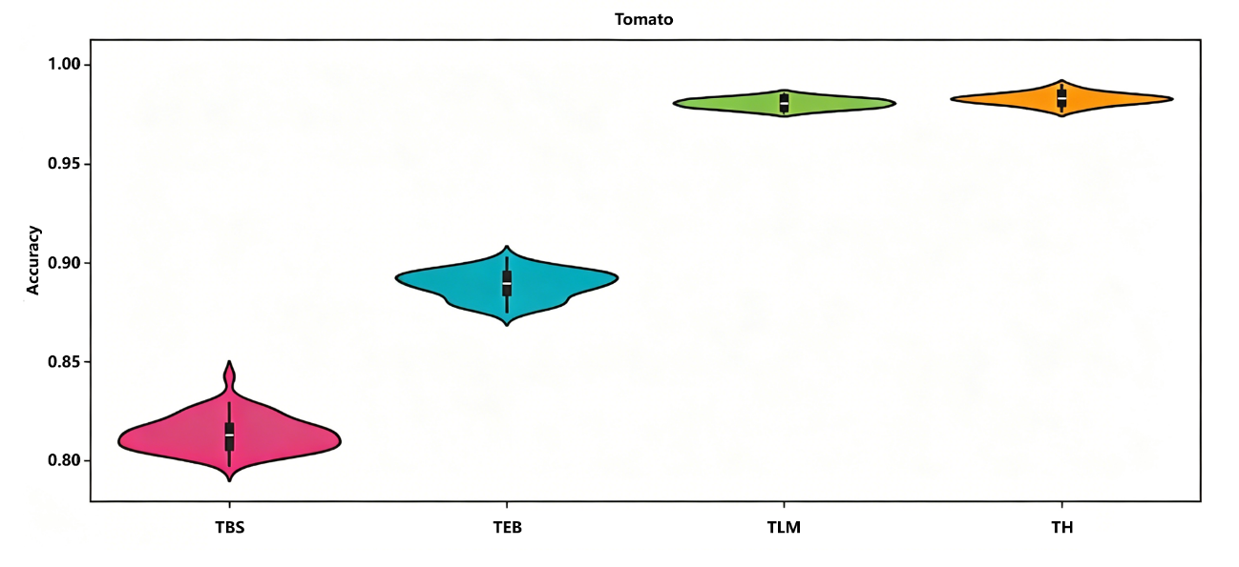
Figure 4.8 Violin Plot of Tomato Disease Identification Accuracy

